Jenkins-task-03
Task 1
Create one Jenkins job using the below code and create three stages:
- stage1: Git clone to download the source code.
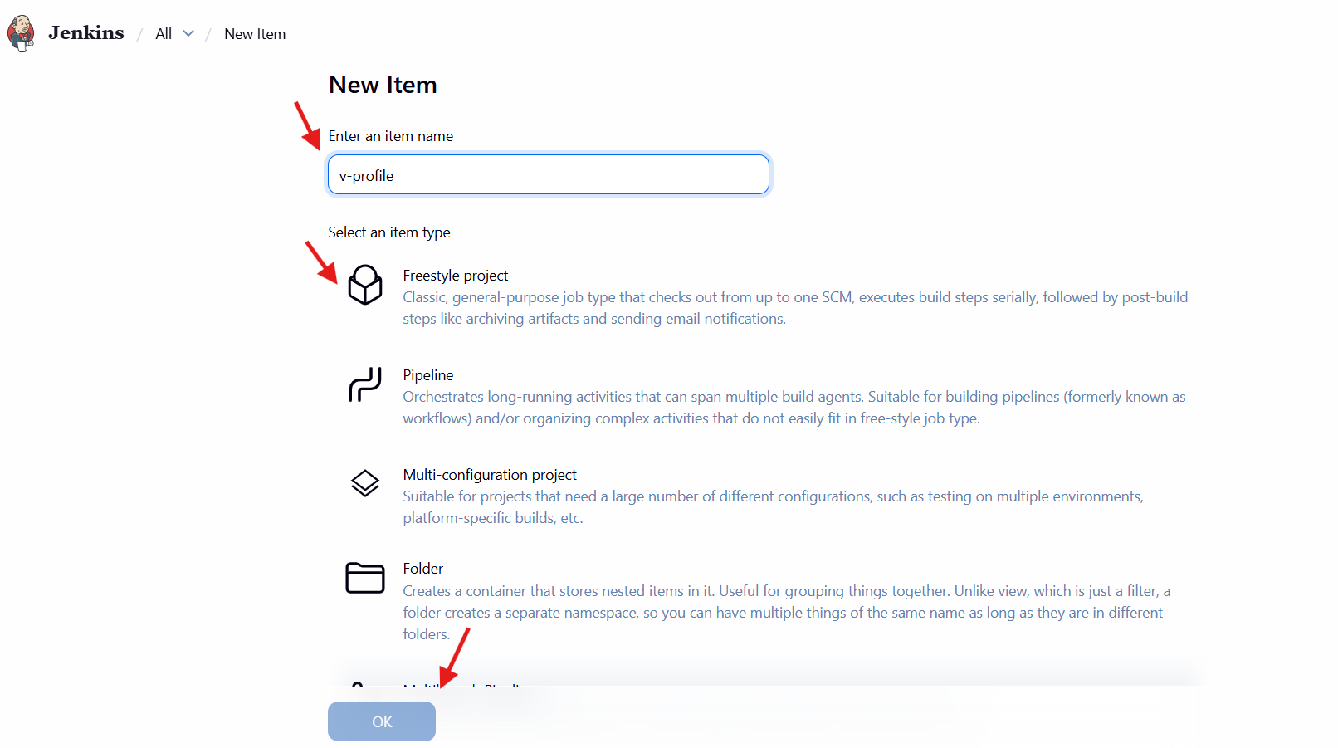
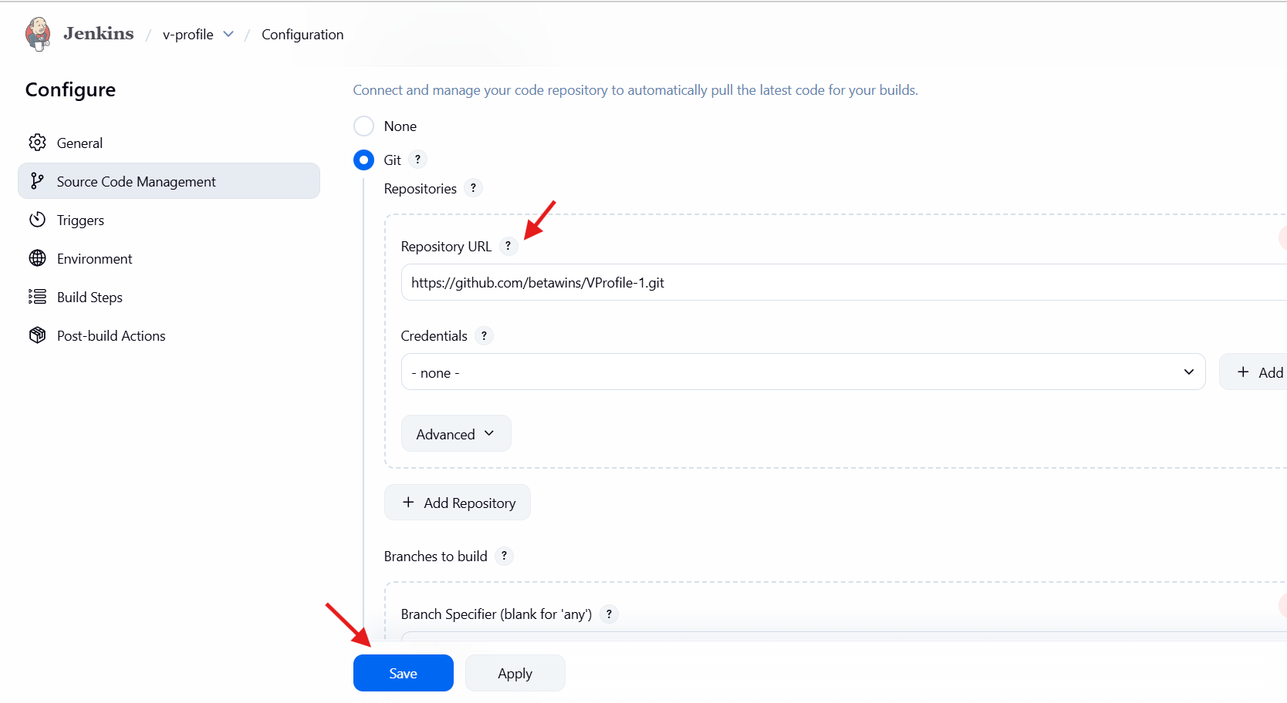
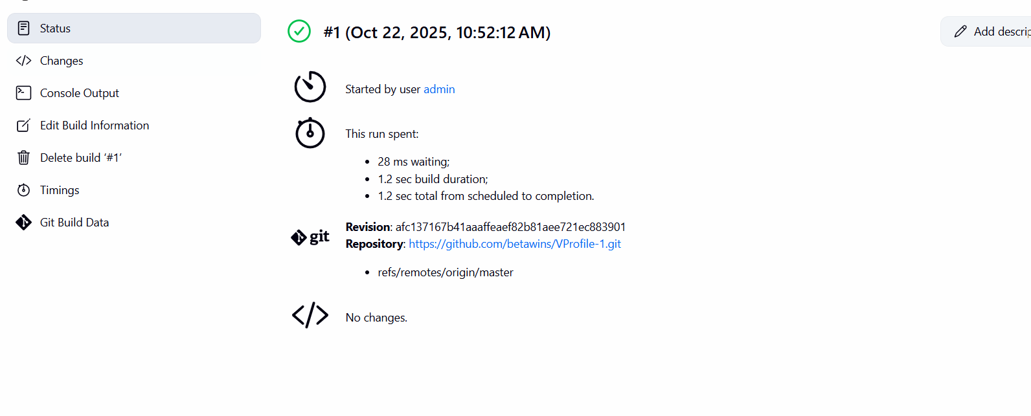
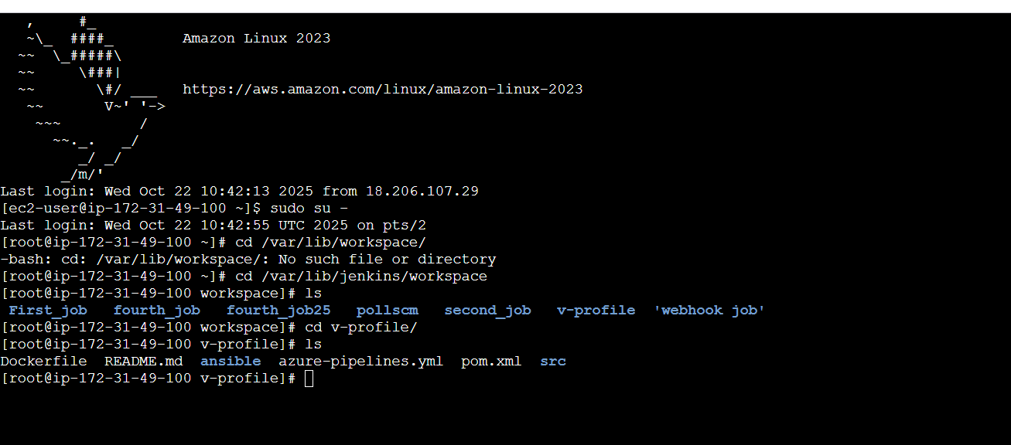

- stage2: Sonarqube Integration to check the quality of code.
Prerequisites: ec2 instance with java 1.8
sudo yum install -y java-1.8.0-amazon-corretto
Use t2 large with at least 20 GB volume
MySQL database server or MySQL RDS instance.
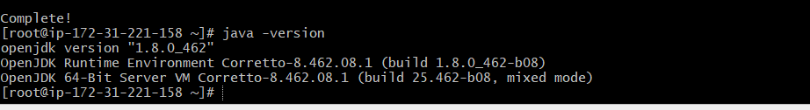
Yum update -y
sudo wget https://dev.mysql.com/get/mysql57-community-release-el7-11.noarch.rpm
• sudo yum localinstall mysql57-community-release-el7-11.noarch.rpm
• rpm --import https://repo.mysql.com/RPM-GPG-KEY-mysql-2022
• sudo yum install mysql-community-server
• sudo systemctl start mysqld.service
• sudo systemctl status mysqld.service

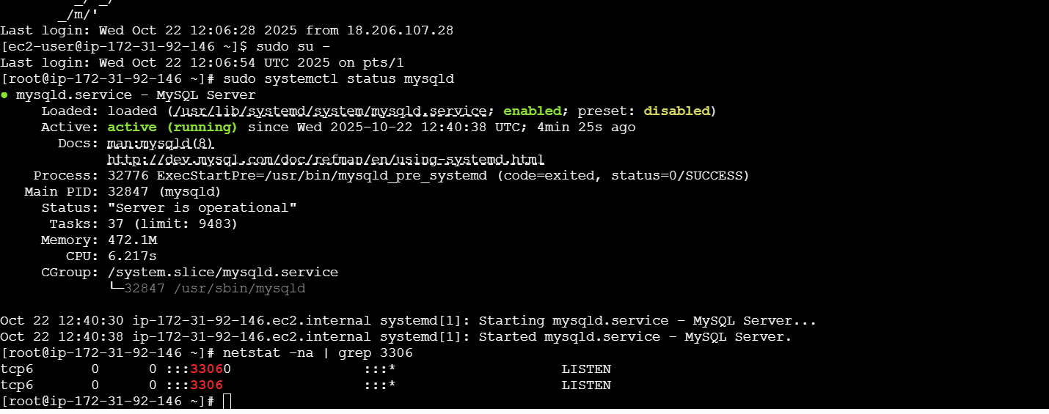
Configure the mysql root password u will see mysql root password
grep 'temporary'/var/log/mysqld.log
Ai<:I0M2%OPE
login to mysql using the default password
mysql -u root -p and enter the default password.
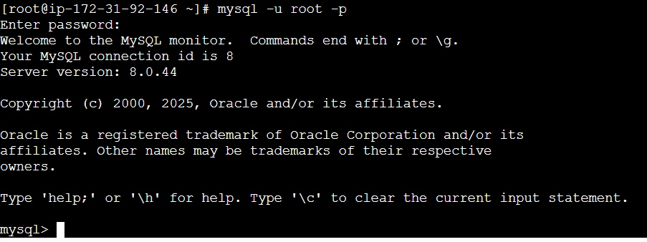
Now, replace the password with the new password
ALTER USER 'root'@'localhost' IDENTIFIED BY 'Admin@123';
FLUSH PRIVILEGES;
Exit
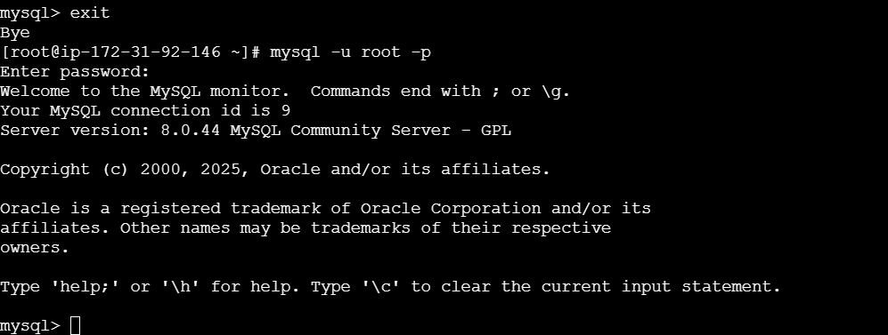
Show databases;
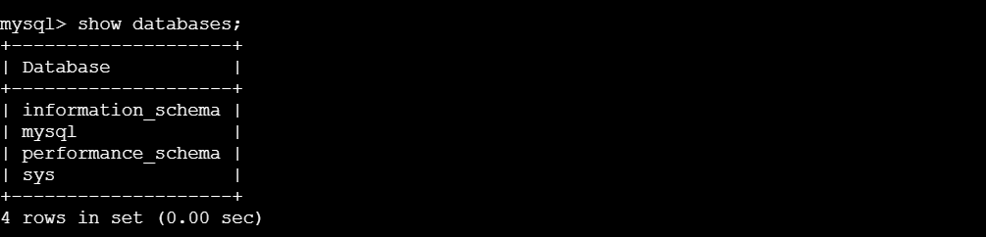
Cd /opt/
wget https://binaries.sonarsource.com/Distribution/sonarqube/sonarqube-6.6.zip
unzip sonarqube-6.6.zip
mv /opt/sonarqube-6.6 /opt/sonar
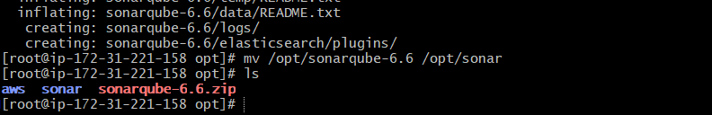
Login to mysql:-
mysql -u root -p
Create a new sonar database:-
Create a new sonar database:-
CREATE DATABASE sonar CHARACTER SET utf8 COLLATE utf8_general_ci;
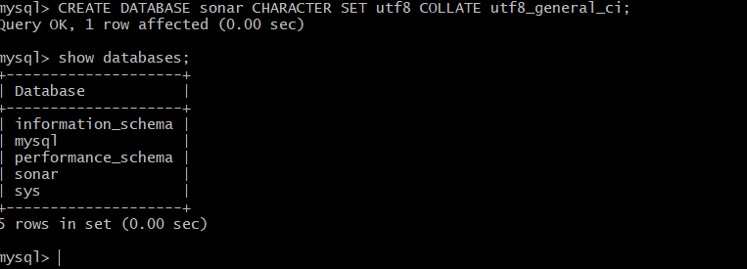
Create a local and a remote user:-
CREATE USER sonar@localhost IDENTIFIED BY 'Sonar@123';
CREATE USER sonar@'%' IDENTIFIED BY 'Sonar@123';
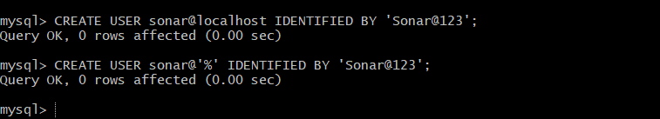
Grant database access permissions to users:-
GRANT ALL ON sonar.* TO sonar@localhost;
GRANT ALL ON sonar.* TO sonar@'%';
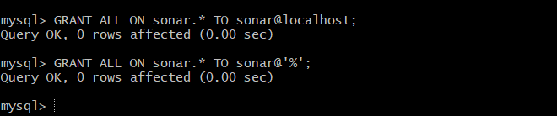
check users and databases:-
show databases;
SELECT User FROM mysql.user;
FLUSH PRIVILEGES;
QUIT
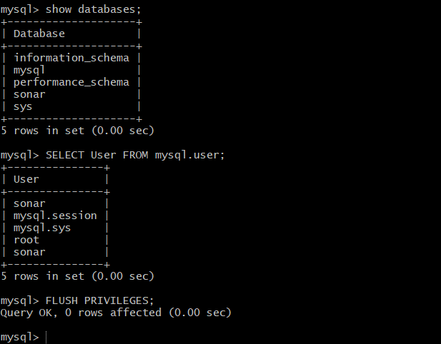
So for you have configured required database information on mysql. Let’s Jump back to your EC2 instance and enable SonarQube properties file to connect his Database.
On ec2 instance
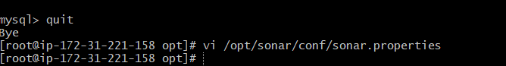
- sonar.jdbc.username=`sonar`
- sonar.jdbc.password=`Sonar@123`
-sonar.jdbc.url=jdbc:mysql://`localhost:3306`/sonar?useUnicode=true&characterEncoding=utf8&rewriteBatchedStatements=true&useConfigs=maxPerformance&useSSL=false
- sonar.web.host=`0.0.0.0`
- sonar.web.context=`/sonar`

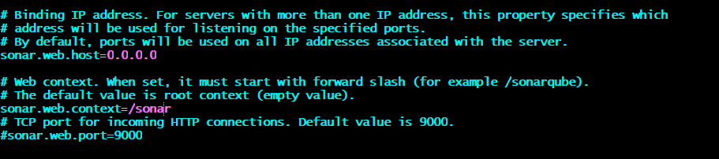
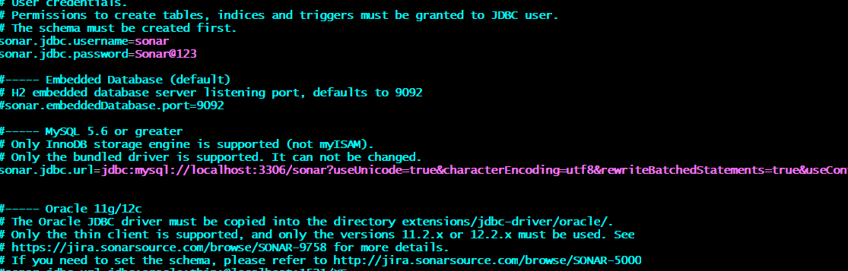
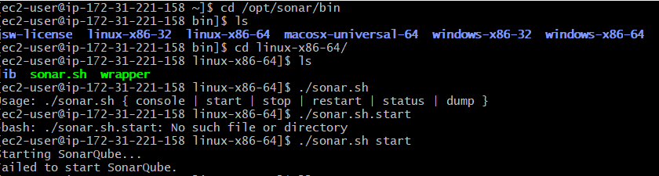
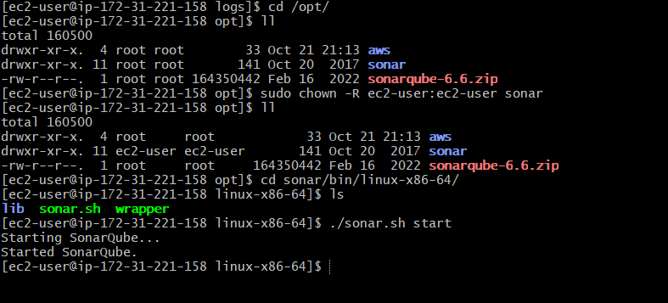
https:url:9000/sonar

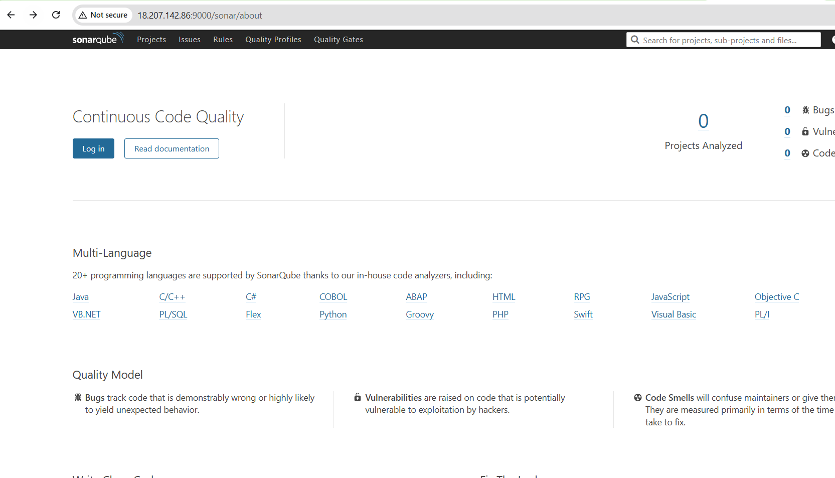

Go to Jenkins-master
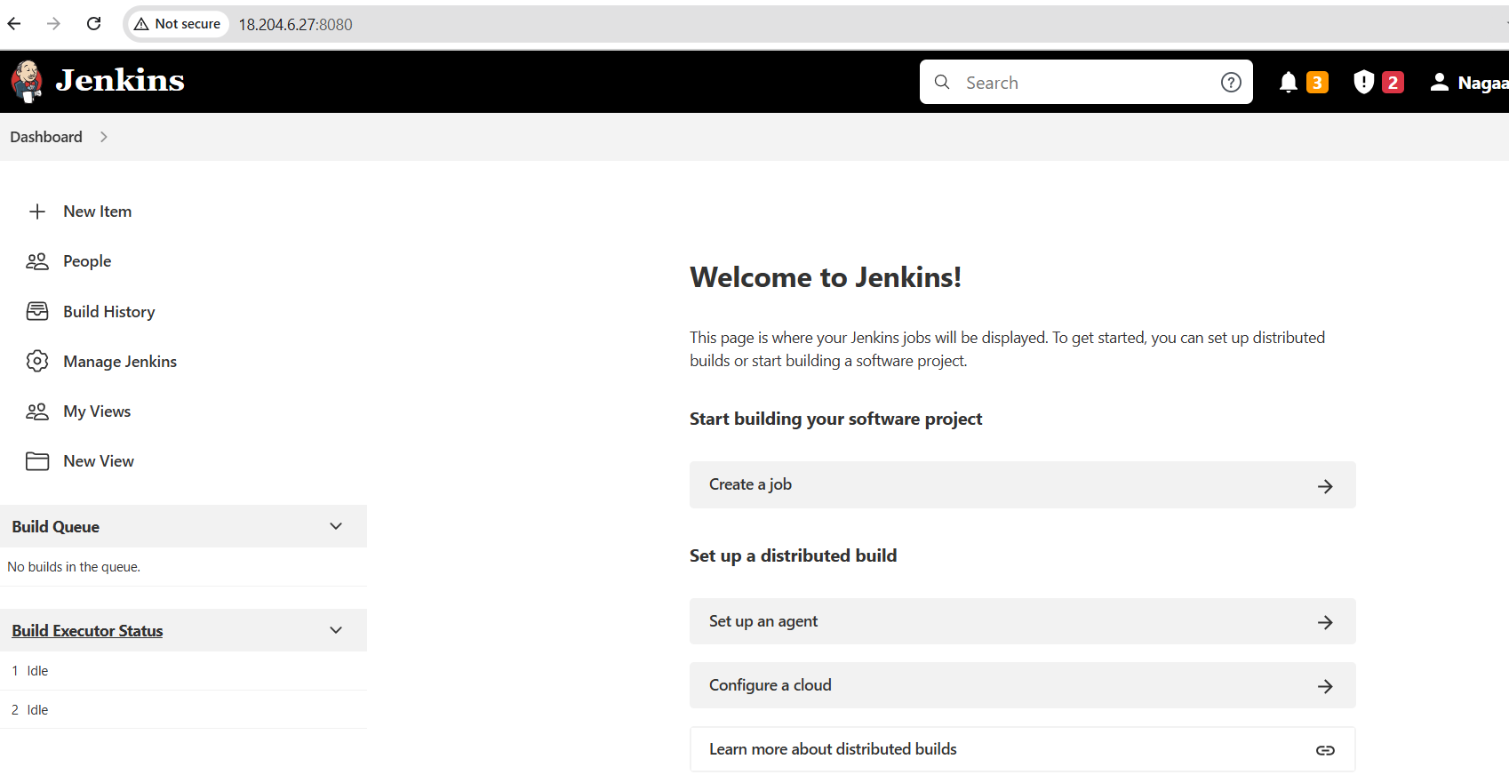
Go to Manage Jenkins → Tools.
Under “SonarQube Scanner installations”, click “Add SonarQube Scanner”.
Name it (e.g. SonarScanner) and check “Install automatically”.
Save.
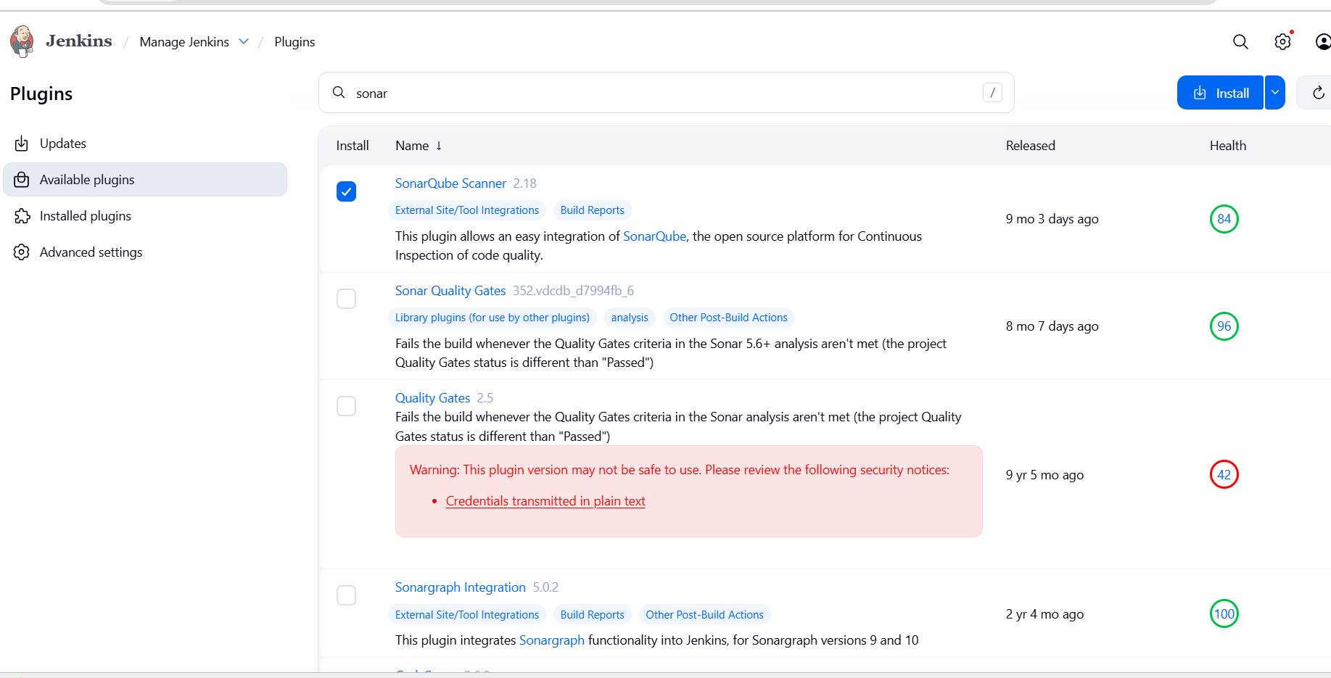
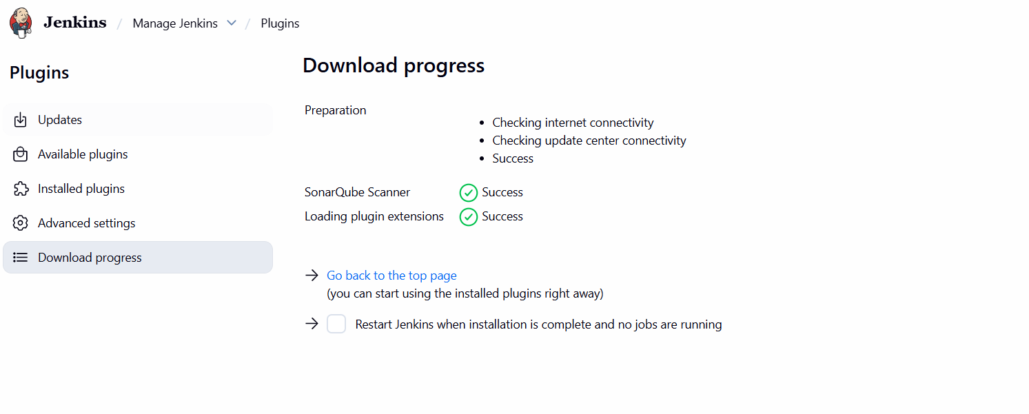

Generate a key in sonarqube
Go to my accountsecurity
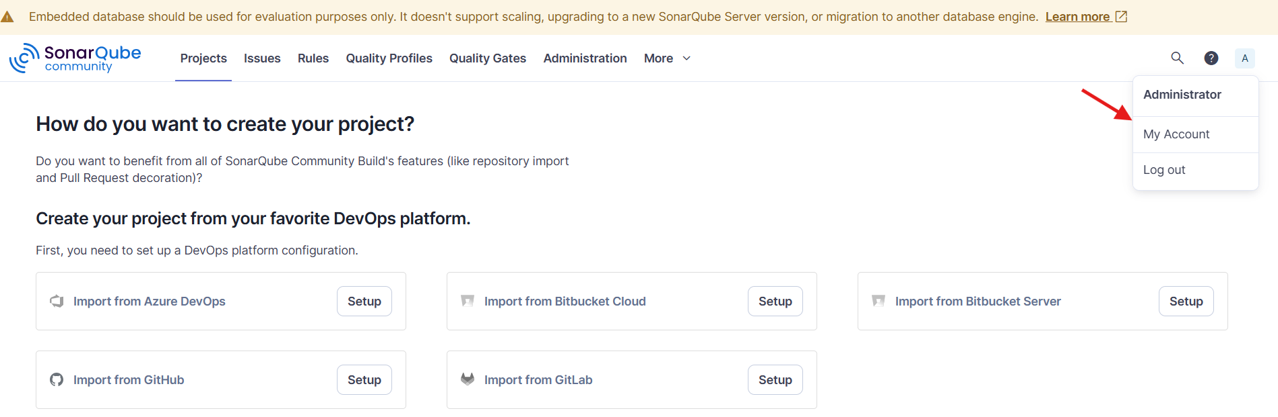
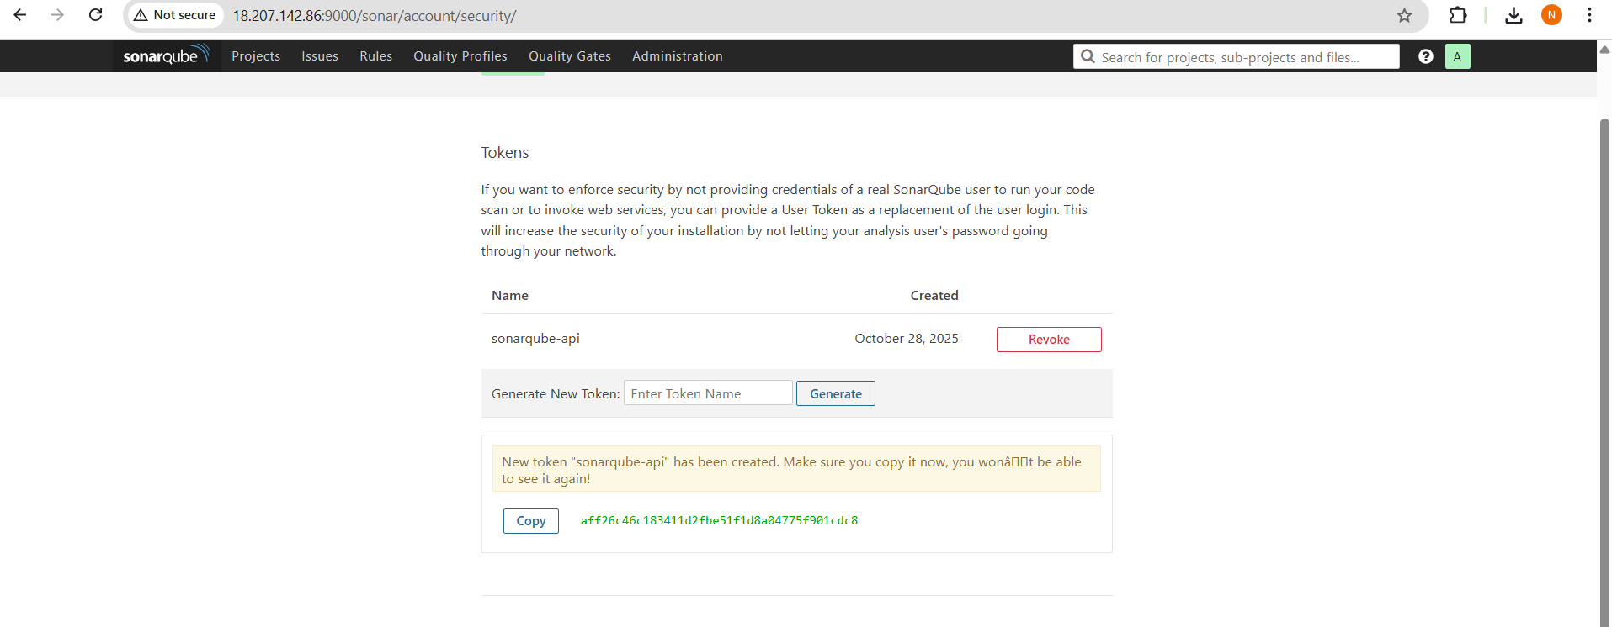

🧩 Step 1: Open Jenkins and Go to Credentials
- Log in to your Jenkins dashboard.
- Click on “Manage Jenkins” → “Credentials”.
- Select a domain (or “(global)” if you want it available everywhere).
- Click “Add Credentials”.

Step 2: Add the SonarQube Token as a Secret Text
- Kind: Secret text
- Secret: (Paste your SonarQube token here)
- ID: e.g. sonarqube-server
- Description: SonarQube-server
Then click “Create” or “Save”.
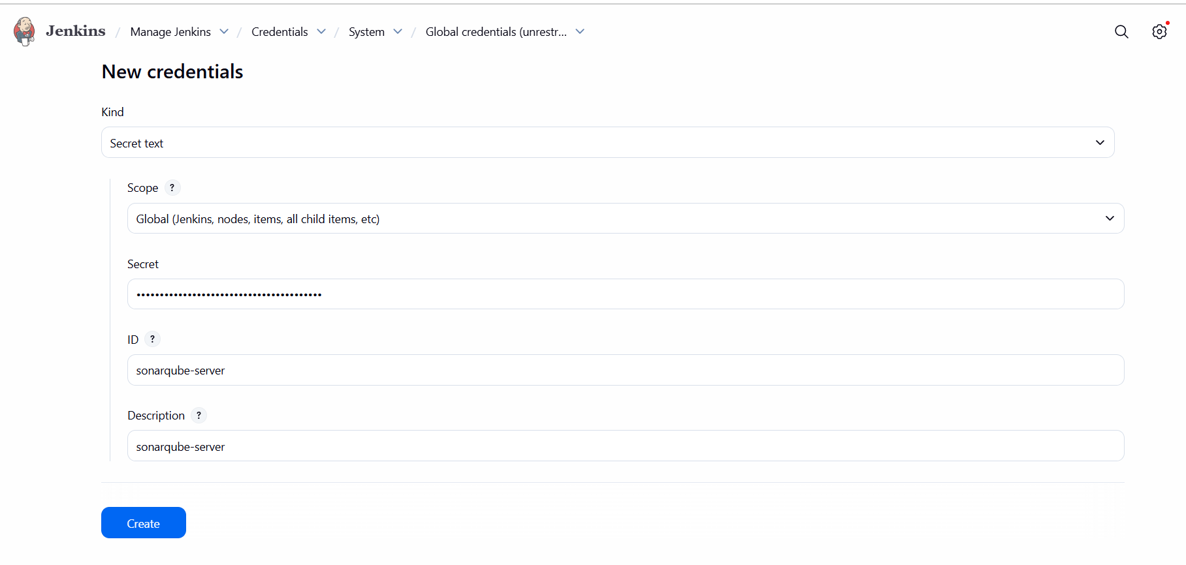
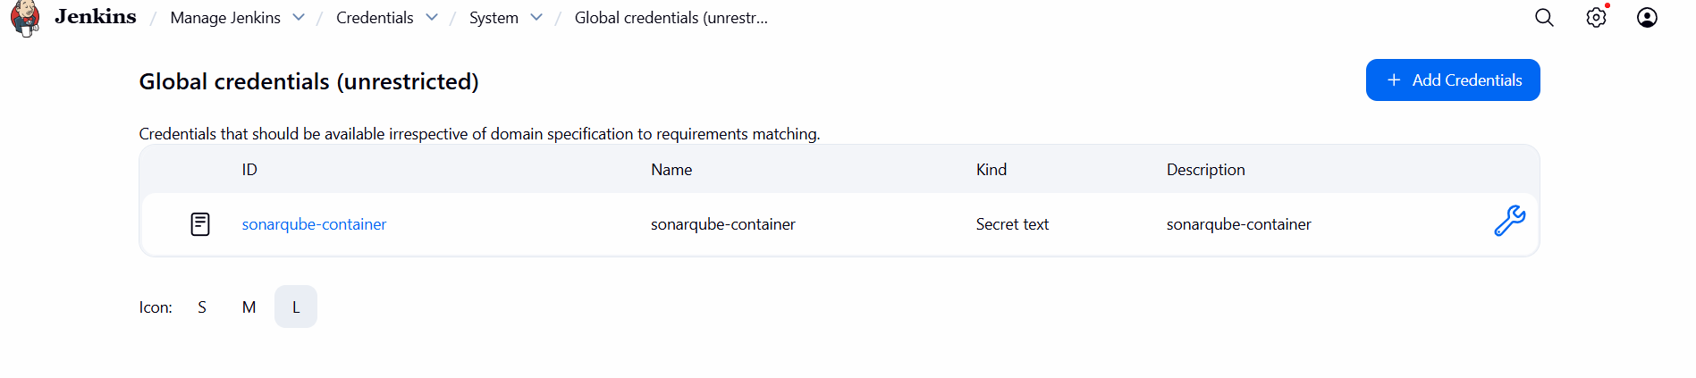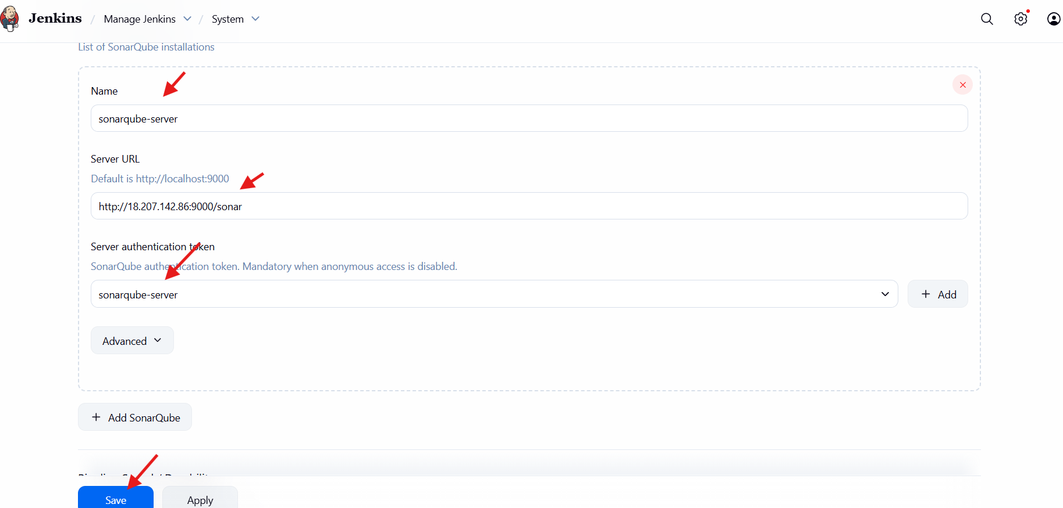
Goto Jenkins server cd /opt/
wget https://binaries.sonarsource.com/Distribution/sonar-scanner-cli/sonar-scanner-cli-4.6.2.2472-linux.zip
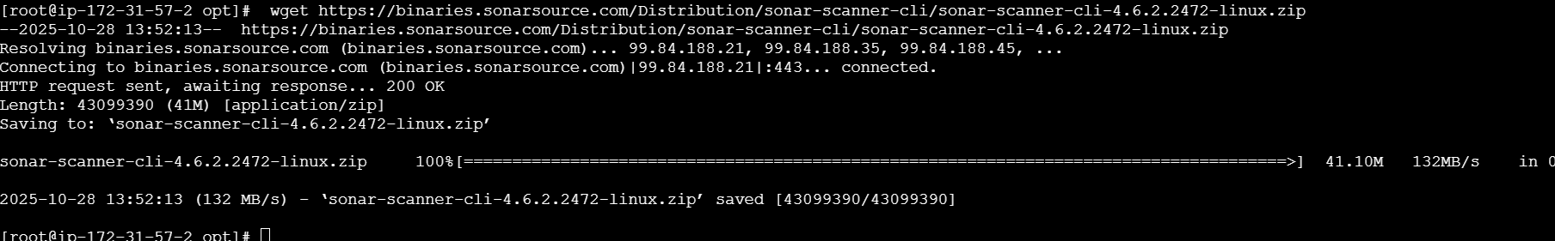
unzip sonar-scanner-cli-4.6.2.2472-linux.zip
mv sonar-scanner-4.6.2.2472-linux /opt/sonar_scanner
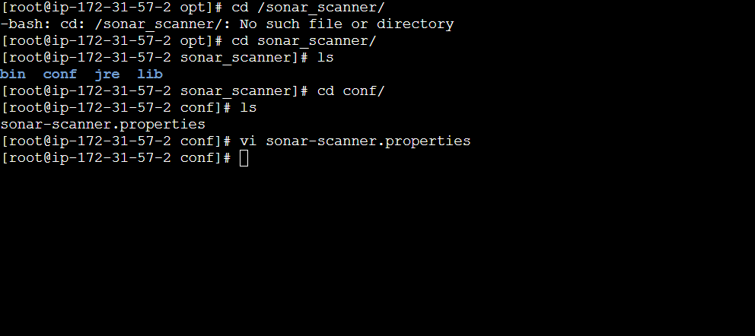
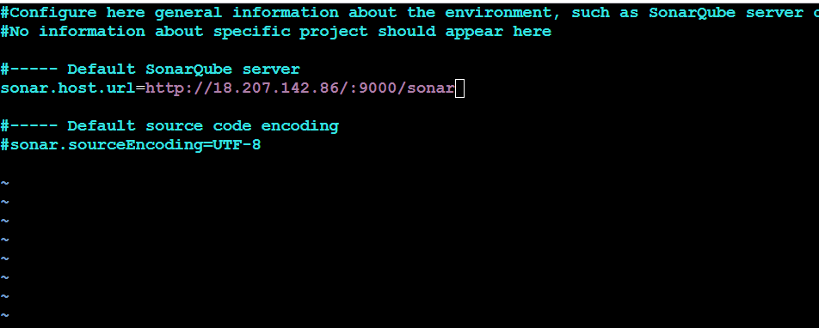
Configure SonarQube scanner home path

-Manage Jenkins` > `Global Tool Configuration` > `SonarQube Scanner installations
- Name : `sonar_scanner`
- SONAR_RUNNER_HOME : `/opt/sonar_scanner/
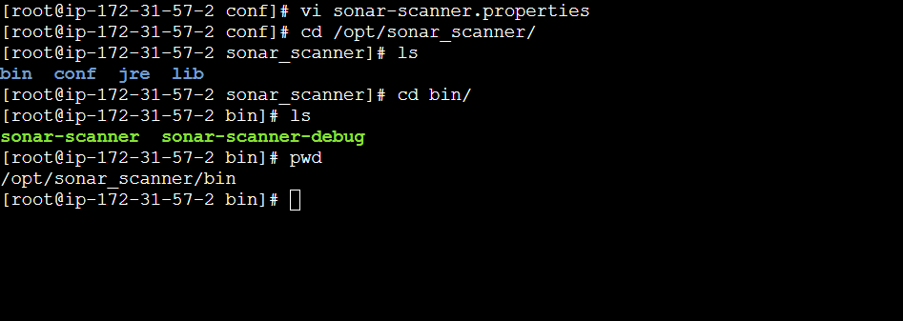
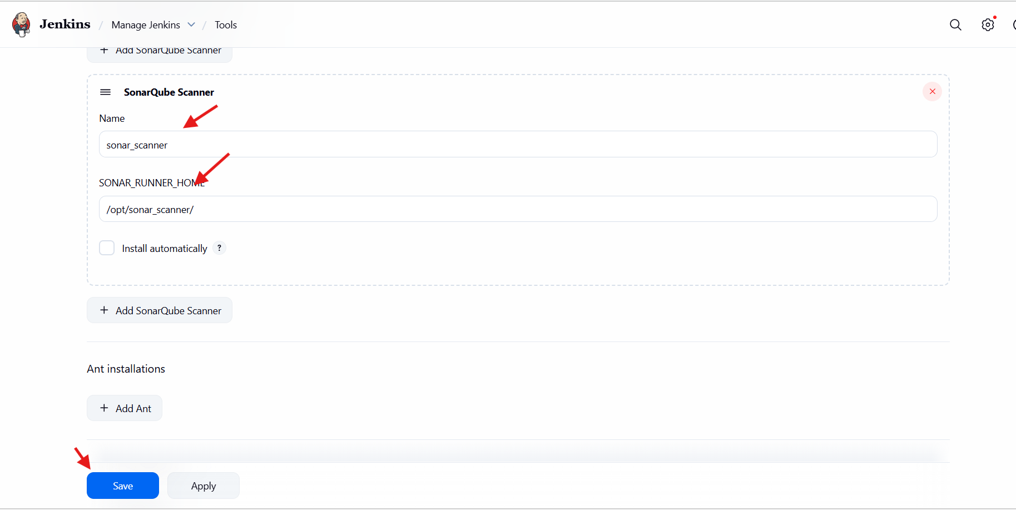
sonar.projectKey=Sabear
sonar.projectName=Sabear
sonar.projectVersion=1.0
sonar.sources=/var/lib/jenkins/workspace/$JOB_NAME/src/
sonar.binaries=target/classes/com/visualpathit/account/controller/
sonar.junit.reportsPath=target/surefire-reports
sonar.jacoco.reportPath=target/jacoco.exec
sonar.java.binaries=src/main/java/com/visualpathit/account/
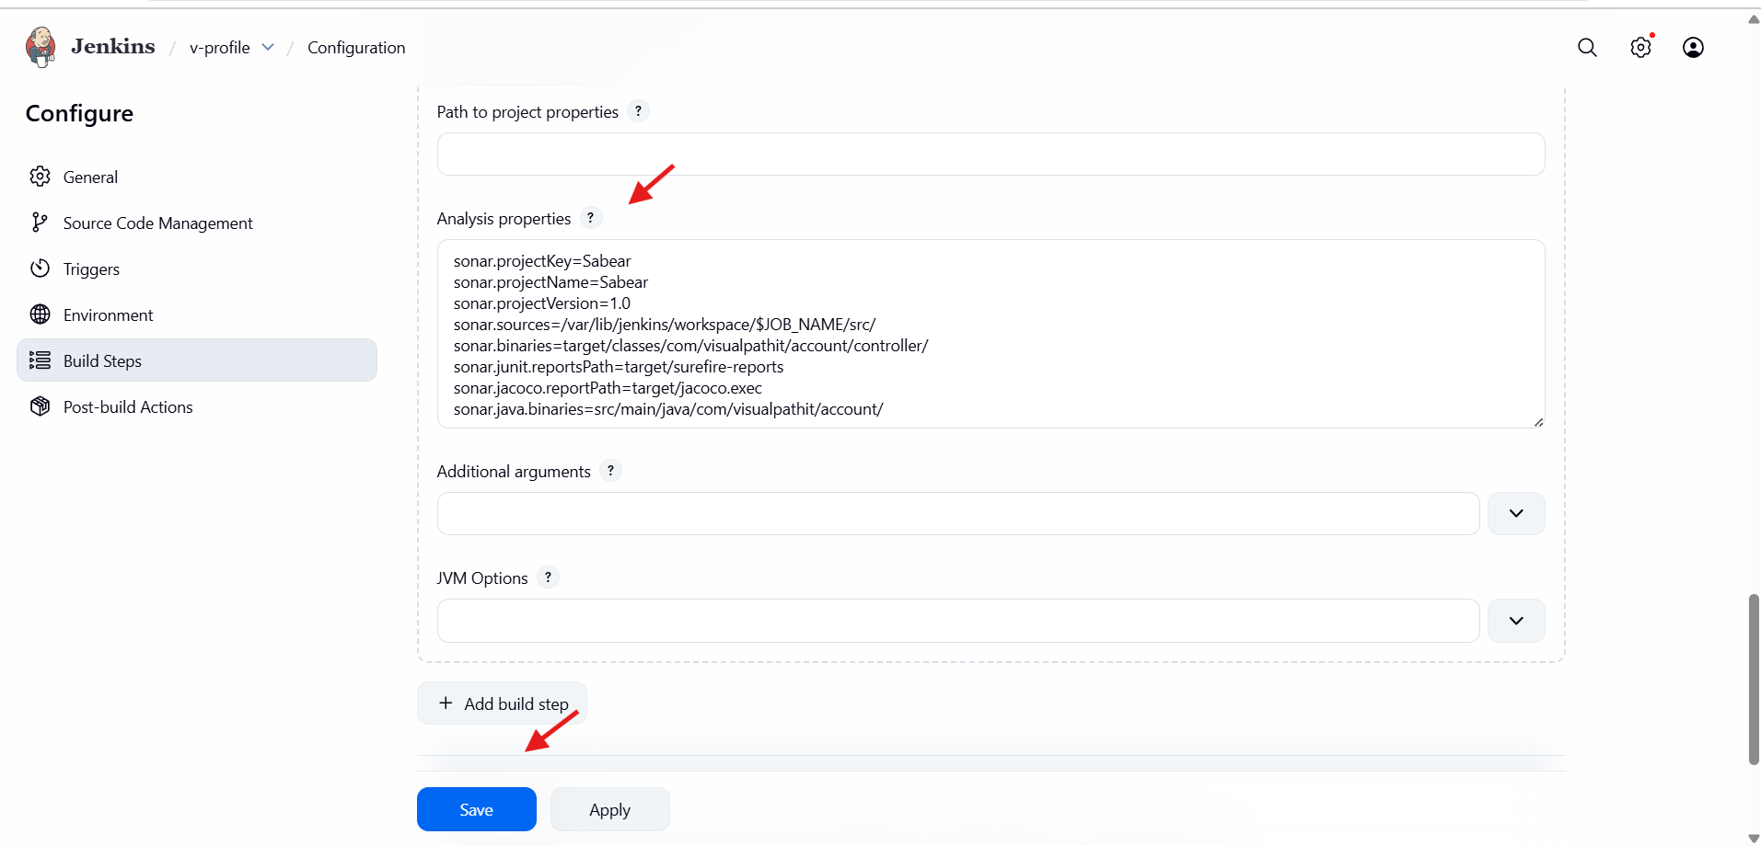

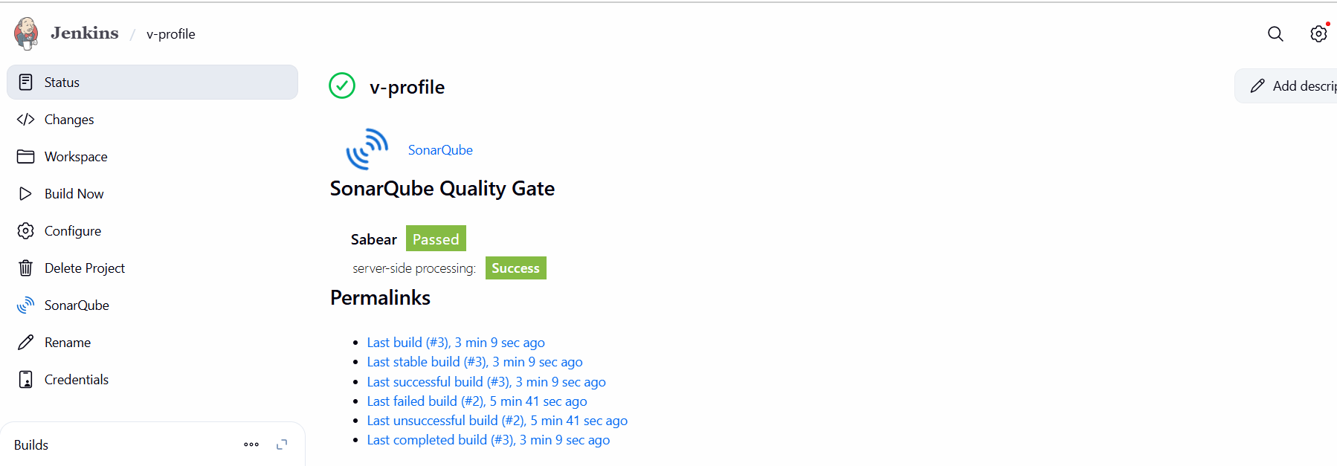
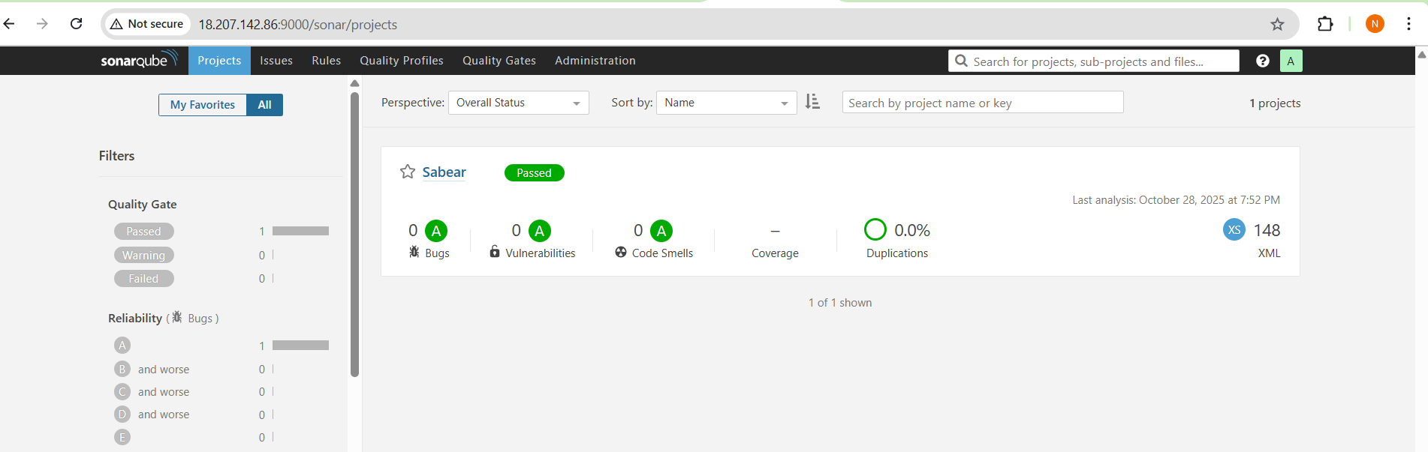

- stage3: Slack Integration to send the alerts to slack.
URL: https://github.com/betawins/VProfile-1.git
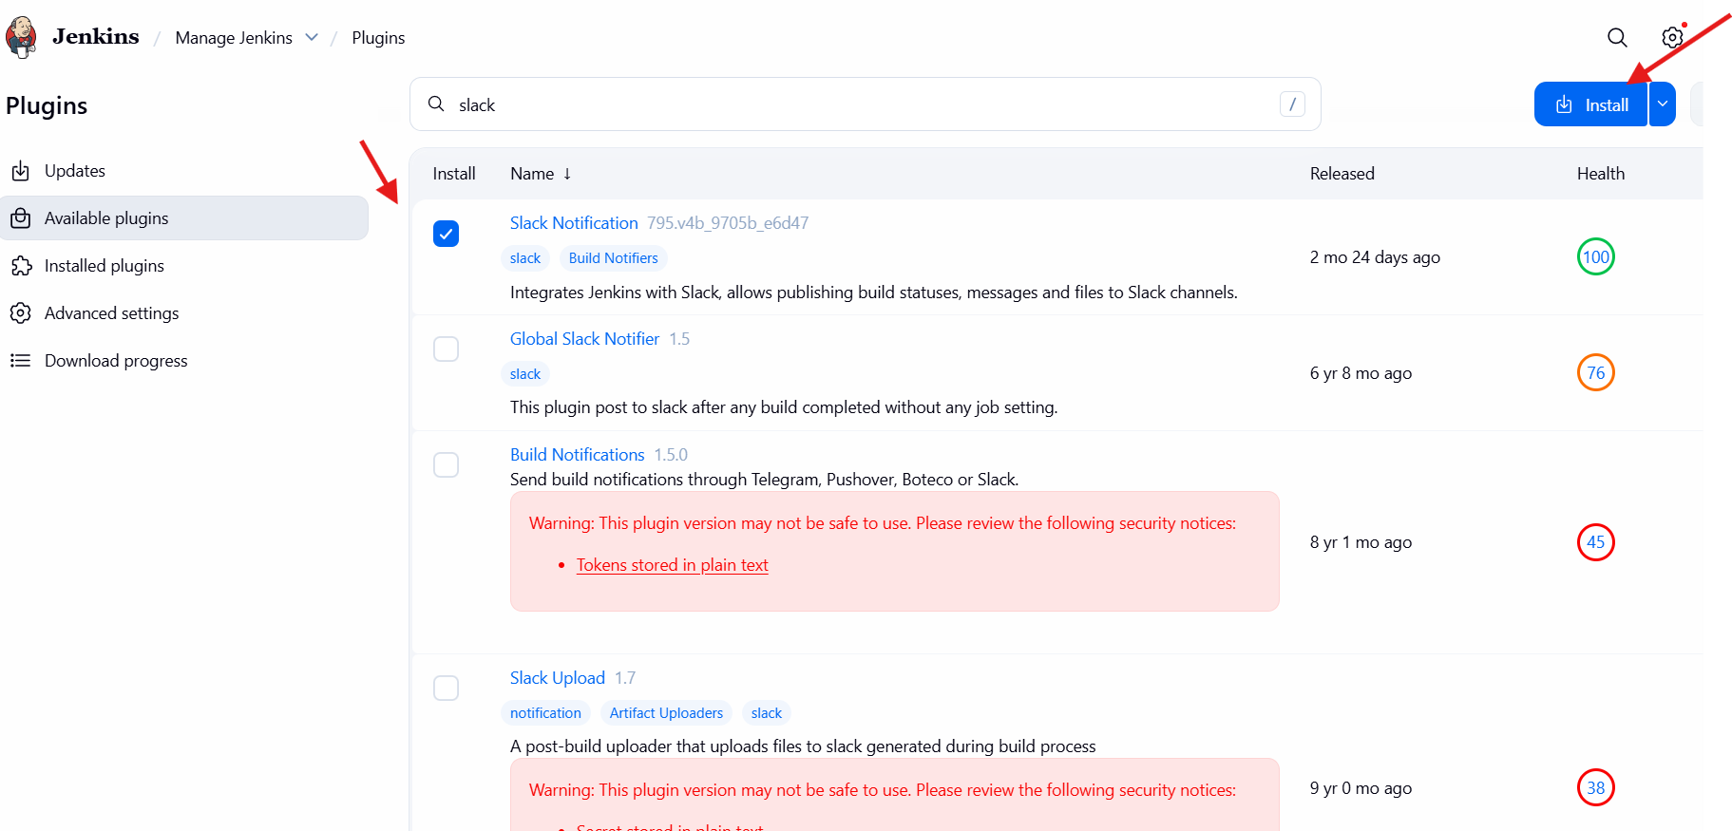
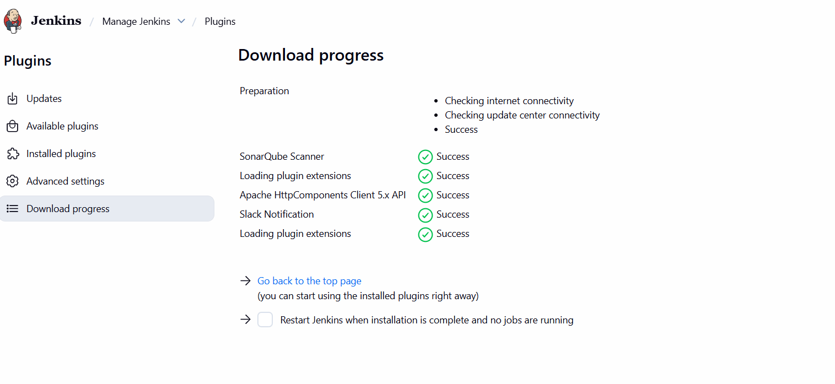
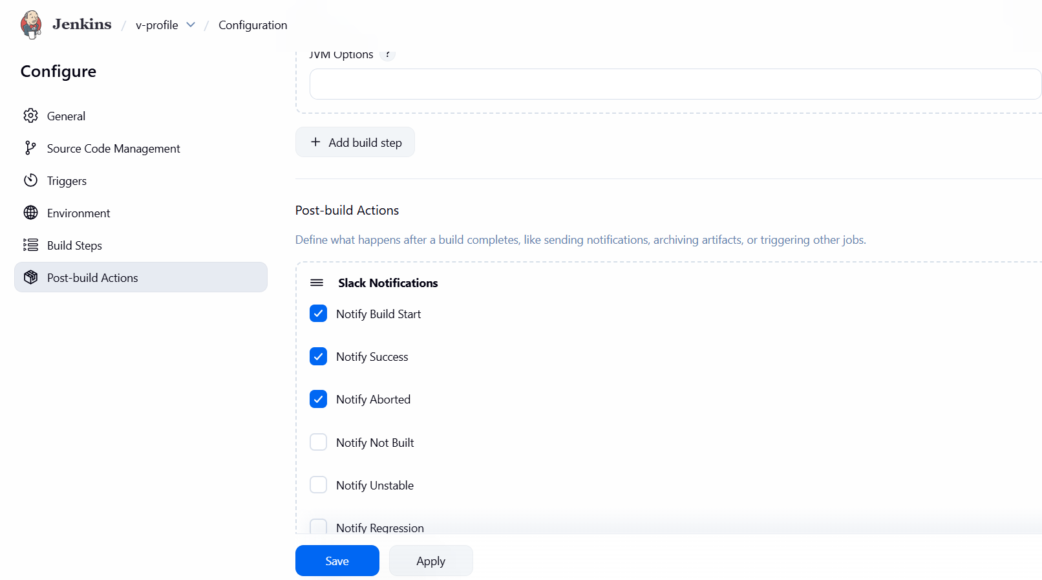

Task 2
Create one Jenkins job using the below code and create three stages:
- stage1: Git clone to download the source code.

- stage2: Sonarqube Integration to check the quality of code.
- stage3: Slack Integration to send the alerts to slack.
URL: https://github.com/betawins/hiring-app.git

